Proposal

Grainger PLC
SVOT Foundation & Renewals Process

Version 4.0
February 7, 2025

Contents
1 Executive Summary 4
1.1 Introduction 4
1.2 The Business Opportunity 4
1.3 The Releases 4
1.4 The Business Benefit 5
1.5 References 5
2 Proposed Solution 6
2.1 Proof of Concept 8
2.2 Solution Overview 15
2.3 Recommended Project Phasing 17
2.4 High-Level Design 23
2.5 Salesforce Licensing 29
2.6 Support 29
2.7 Training 29
2.8 Prerequisites 29
2.9 Exclusions 30
2.10 Assumptions 30
3 Detailed Costs & Timelines 33
3.1 Release 1 - Single View of Tenancy 34
3.2 Release 2 – Renewals 35
3.3 Dependencies 35
4 Delivery Approach 36
4.1 UAT 37
4.2 Project Management 37
4.3 Availability 37
5 Acceptance 38

Executive Summary

Introduction
Grainger plc have engaged with Open Box to redesign the existing residential Renewals Journey in their Salesforce org.
​​The renewals process is currently shoehorned into the Salesforce leasing journey which is designed primarily for new leases. Many key inputs for this process are held out of system (including price book rent in spreadsheets) or in other systems (such as arrears balances in Qube), requiring considerable manual effort to cross-check data between systems and input this data into offline spreadsheets that are circulated between teams.
Limitations with the existing portal in which tenants review offers result in tenants being regularly unable to access the portal and prevent offers for multiple units (such as a renewal for a flat & a parking bay) from being sent at the same time.
Additionally, the likely introduction of the Renters’ Rights Bill in 2025 must be considered as this will have a notable impact on the renewal process for the majority of Grainger’s tenants.

The Business Opportunity
Grainger have identified that redesigning the renewals process would reduce the significant manual effort, cost of late renewals and void days.
Additionally, it has become clear from the analysis that there is a need to enhance Grainger’s existing single view of customer (SVOC) by providing a single view of a tenancy within Salesforce. Accurate and up-to-date tenancy data is foundational to delivering an enhanced renewals journey, as well as other Salesforce functionality – such as functionality to support Right-to-Rent compliance – without relying on manual workarounds.

The Releases
The scope of this project is to deliver two releases:
- Release 1 - Create the foundation for single view of tenancy within Salesforce, as part of the overarching goals of a single view of customer and single view of property.
- Release 2 - Enhance the residential renewals journey to replace the existing tenant portal for renewal offers and the offline renewal spreadsheets, thereby delivering functionality that will remain relevant once the Renters’ Rights Bill is enacted.
  - This project would therefore redesign the initial steps in the renewals journey, up to the point that the tenant accepts the offer. Thereafter, the existing renewal process and functionality will remain in place for Release 2. Enhancements to accommodate the Renters’ Rights Bill will be addressed in a subsequent project.
  - The solution will minimize manual data entry, eliminate the need to cross-check information between Salesforce and Qube, and maintain a full history of offers and counteroffers.

The Business Benefit
The proposed solution will help to:
- Improve speed & efficiency of the process, allowing business to scale operations without necessitating a linear increase in headcount.
- Obtain notice to quit from tenants earlier in the process, minimizing void days and void costs.
- Obtain renewal preferences from tenants upfront, allowing for renewal offers to be tailored and reducing delays.
- Highlight renewals approaching deadlines to avoid delayed rent increases.
- Build the foundation for a single view of customer within Salesforce.
- Improve the tenant experience with a robust online platform.
- Reduce offline communications between teams.
- Provide a single source of truth for renewal data.
- Reduce data entry errors.

References
Along with this proposal, Open Box have also delivered the following artefacts:
- Grainger - Renewals – As Is Process Diagram v1.0.pdf
- Grainger - Renewals – Proposed Future State Process Diagram v2.0.pdf

Proposed Solution
Open Box proposes to deliver two releases:
- Release 1 - Single View of Tenancy Foundational Release – This release will deliver foundational functionality that may be incrementally built on, allowing for future integration and workflow automation in later iterations. This release will address the following objectives which are further detailed in the feature backlog:
  - Align Salesforce & Qube Tenancy Data Model – Create the concept of a tenancy in Salesforce that maps directly to existing Qube tenancies.
    - While Qube remains the system of record for tenancies, aligning the data model will provide a single view of all tenants, related parties, associated opportunities and the existing tenancy version history within Salesforce.

    - The solution will maintain an accurate record in Salesforce of which tenancies and tenants are current/active and which have vacated, as well as move in and move out dates for each tenant, that is consistent with Qube.
  - See Current Tenancy Arrears – as part of tenancy information.
  - Import Passing Rent, renewal denied flag and other relevant tenancy data from Qube into Salesforce which would be visible as part of tenancy information.
  - See a History of Price Book Rent & ERVs – Enable support users to upload spreadsheets containing Price Book Rent, Grainger Trust prices, March and September ERVs and license prices into Salesforce as and when updated. Allow users to see a history of ERVs and price book rent for a unit, over time, within Salesforce.
  - Enable Omni-Channel Communications – Allow users to communicate with tenants through a variety of channels (including WhatsApp) and access a full history of those communications in Salesforce.
- Release 2 - Renewals Journey Enhancements – This release will enhance the existing residential renewals journey in Salesforce by replacing the current tenant renewal portal and spreadsheets and providing a foundation for the anticipated Renters’ Rights Bill. This release will address the following objectives which are further detailed in the feature backlog:
  - Automatically Create Renewal Opportunities – based on up-to-date tenancy data, incorporating the latest ERVs and price book rent, and thereby replacing the lease end diaries in Qube.
  - Receive Early Intention to Renew – Prior to offering, allow tenants to provide an indication of whether they intend to renew, request changes to lease terms, or raise issues that may affect renewal & notify the relevant users.
  - Approve Renewals – Enable Property Mangers (PMs) & Resident Services Mangers (RSMs) to review upcoming renewals, and indicate whether to renew, deny or defer the renewal.
  - Set Renewal Offer & Minimum Price – Enable Asset Managers (AMs) to review upcoming renewals, ERVs, price book rent and set an offer and minimum price.
  - See Projected Growth on Rent for Current Renewals – Replace the existing ‘Summary’ worksheet in the Renewals spreadsheet with a dashboard that enables Asset Managers to see growth on rent by asset and region, by comparing passing rent and renewal prices for all renewals in a given month.
  - See Unit Condition & Pricing Factors – Enable PMs/RSMs to maintain unit condition and block-level pricing factors in Salesforce which Asset Managers can see when reviewing renewal pricing.
  - Manage Renewal Requests & Blockers – Enable PMs/RSMs to indicate where there is an issue blocking a renewal, and capture the outcome of tenant requests and renewal blockers.
  - Monitor Renewal Progress – Enable Renewals Negotiators to see outstanding information, blockers and any renewals at risk of missing deadlines at a glance.
  - Respond to Offers Online – Prepopulate offer details, and enable tenants to respond to offers online by accepting, giving notice to quit, or making a counteroffer. Tenants may review offers for multiple units at the same time.
  - Manage Counteroffers & AM Approval – Notify Renewal Negotiators of counteroffers and require Asset Management approval where necessary, maintaining a full history of offers and counteroffers.
  - Initiate an End of Tenancy – where a tenant provides notice to quit or there is an internal move.

Proof of Concept

Using LWC Data Tables to Replace the Renewals Spreadsheet
Open Box proposes to replace the Renewals Spreadsheet with custom Lightning Web Components (LWC) based on the standard LWC data table component. Each team would have access to a table that provides a list of renewals and information relevant to them, allowing them to view and edit in bulk similar to an Excel spreadsheet.
The decision to use a LWC rather than a report or list view is based on the need to create complex derived columns that do not correspond directly to an Opportunity field and to provide custom features such as conditional cell formatting.
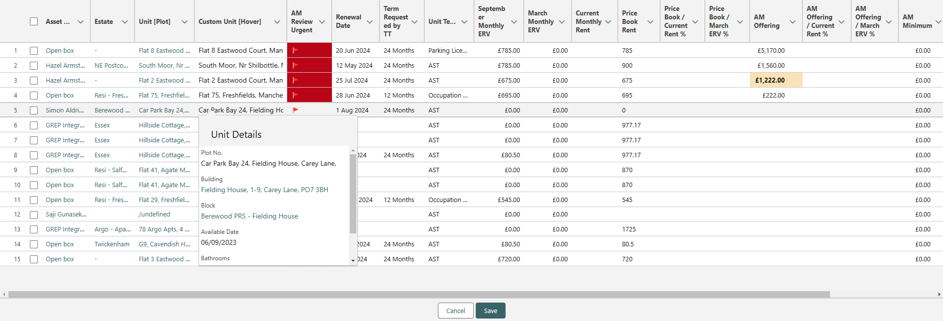
Figure 1: Proof of Concept – LWC Data Table for Asset Management Review
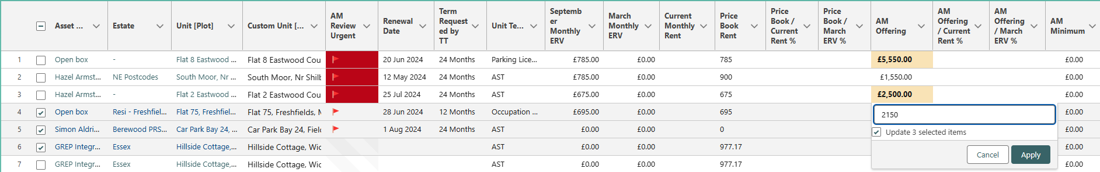
Figure 2: Proof of Concept - Bulk Updates
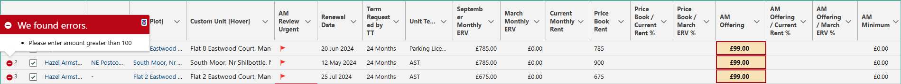
Figure 3: Proof of Concept - Validation Error Display
The LWC data tables allow for the following functionality:
- Filters
- Bulk updates
- Calculated fields
- Display information from related objects (e.g. display the latest price book rent for the related month).
- View information in a hover over instead of adding further columns.
- Display validation error messages and highlight fields that fail validation.
- Action buttons for bulk updates.
- Conditional formatting of individual cells/values.
- Display colour-coded flags.
Open Box proposes to provide a renewals console that displays each team’s renewal list as well as a combined view of the existing dashboards used by Asset Management and a new report of Projected Growth on Rent.
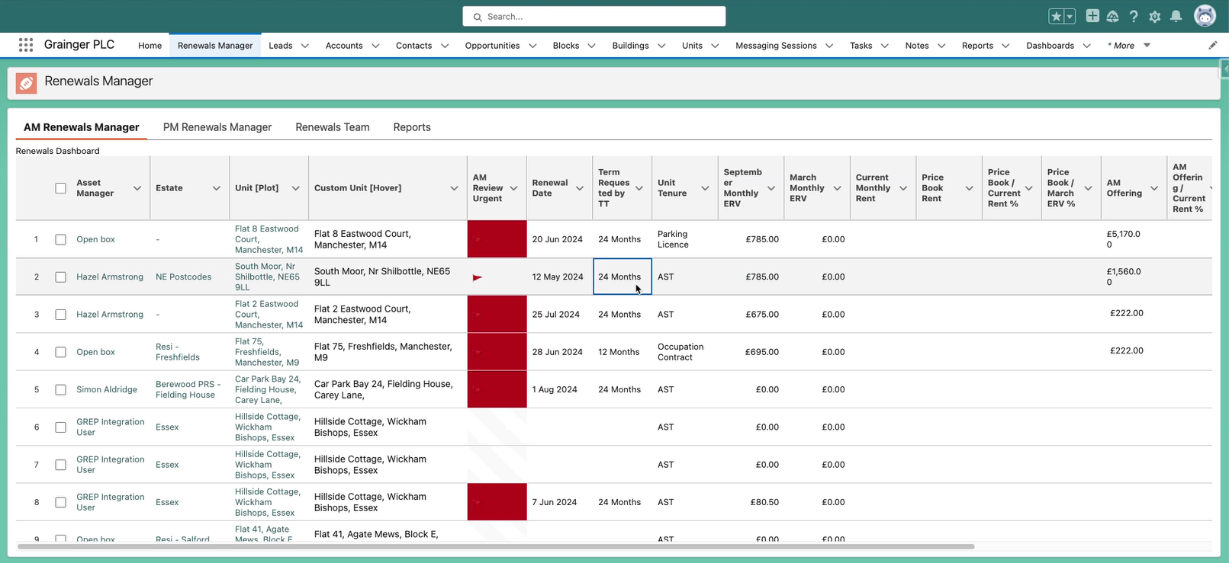
Figure 4: Proof of Concept - Renewals Manager Console
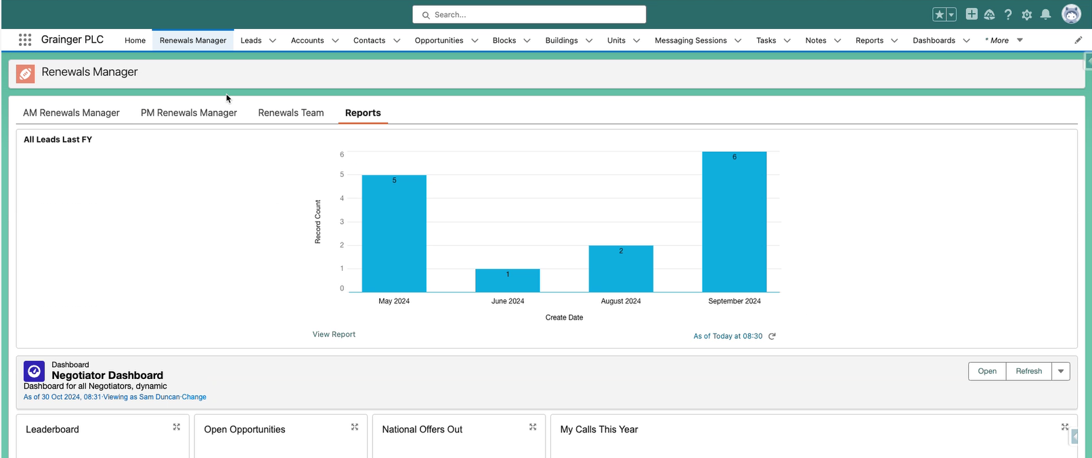
Figure 5: Proof of Concept – Consolidate Reports & Dashboards for Asset Management Review onto a Single Screen

Using Form Assembly to Replace the Renewals Portal
Open Box proposes to use Form Assembly to enable tenants to provide initial feedback on their intention to renew as well as to review renewal offers.
Form Assembly provides the following functionality:
- Open the form from a link in an email.
- Real-time offer and opportunity data is displayed to the user.
- Dynamic form prompts the user to provide relevant information based on options selected.
- Validations can be applied (e.g. preventing tenants from responding to the same offer multiple times).
- Responses are saved in the applicable fields on the offer and/or opportunity.
- Responses can trigger new record creation (e.g. create a task assigned to PM if the tenant requests a different unit).
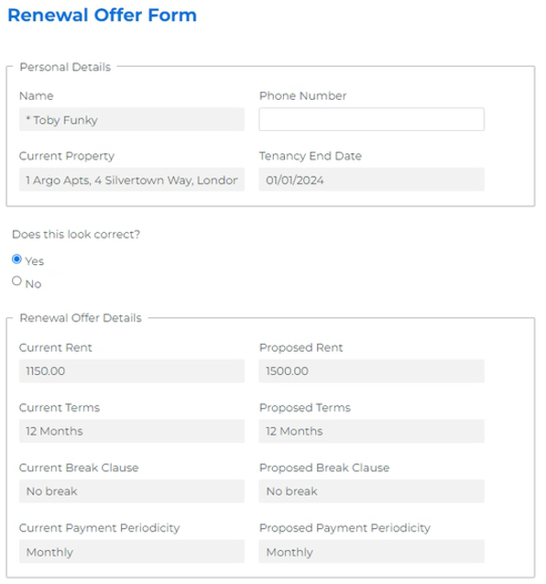
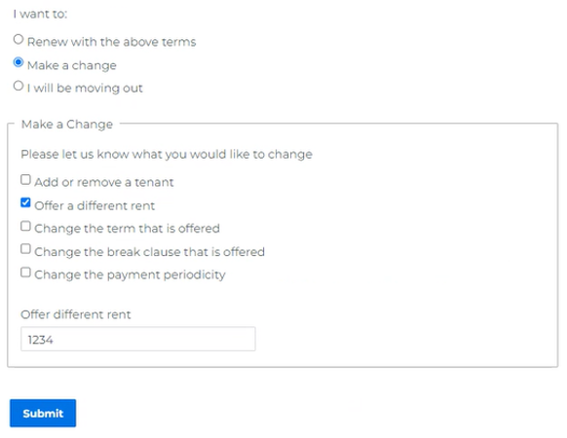
Figure 6: Proof of Concept - Tenant Reviews & Responds to Offer

Storing Pricebooks in Salesforce
Open Box proposes to use the standard Pricebook2 and PricebookEntry objects to hold the monthly pricing for every unit for 12 months into the future.
The setting of the pricing would remain offline using the existing spreadsheets, but pricing would then be loaded into Salesforce via a manual monthly process. This means that at the point of renewal, Salesforce can automatically pull the correct ERVs and price book rent based on the starting month of the renewed period.
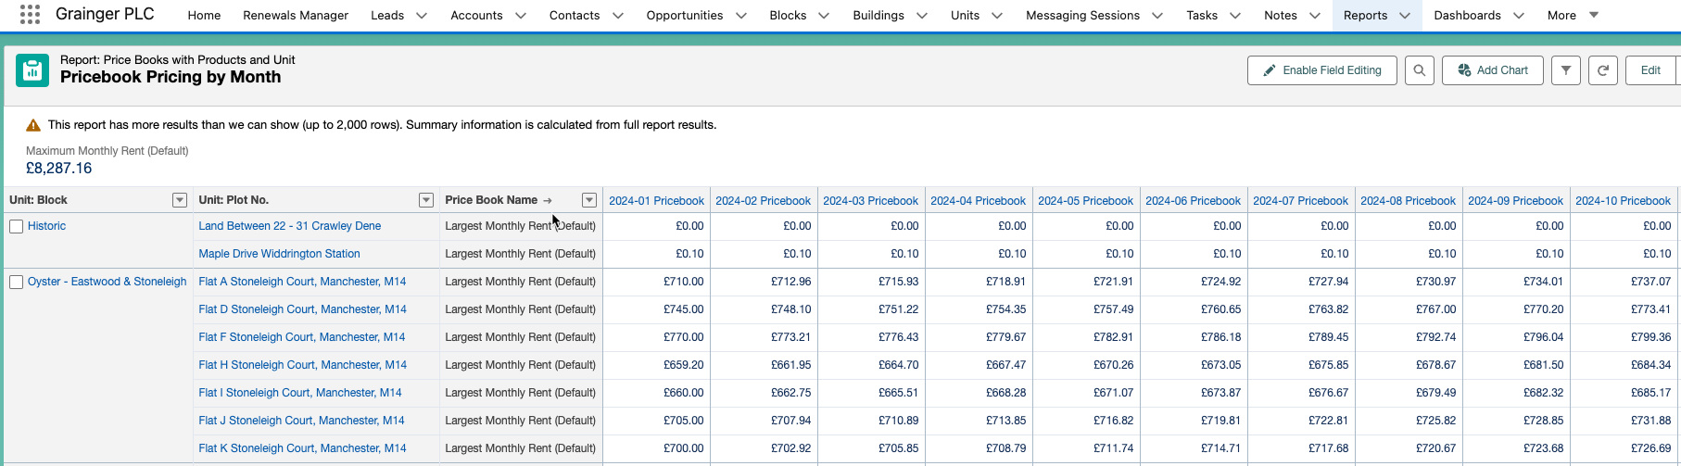
Figure 7: Proof of Concept - Pricebook Rent Report
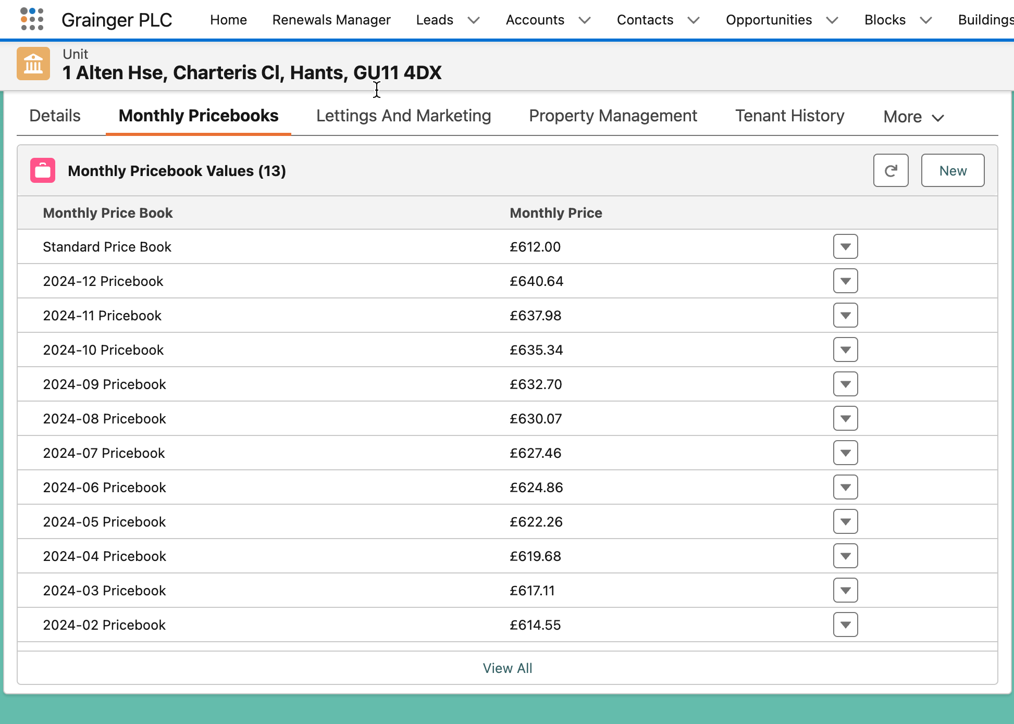
Figure 8: Proof of Concept - Viewing Pricebook Entries for a Unit

Email Threading
Where a tenant responds to a system-generated, or user-initiated, email that is sent from Salesforce, the tenant’s reply can be threaded onto the relevant objects. For example, if a tenant replies to a Salesforce-generated email about a renewal opportunity, the reply can be displayed in the activity timelines for the relevant opportunity, tenancy as well as tenant (account). Users may be notified of tenant replies (or bounced emails) via a task, email or system notification.
Email threading on objects can be achieved by including a threading token on email templates, using an org-wide email address that will forward to a unique Salesforce address. This functionality is available on custom and standard objects using threading tokens delivered in the Summer ’24 release.
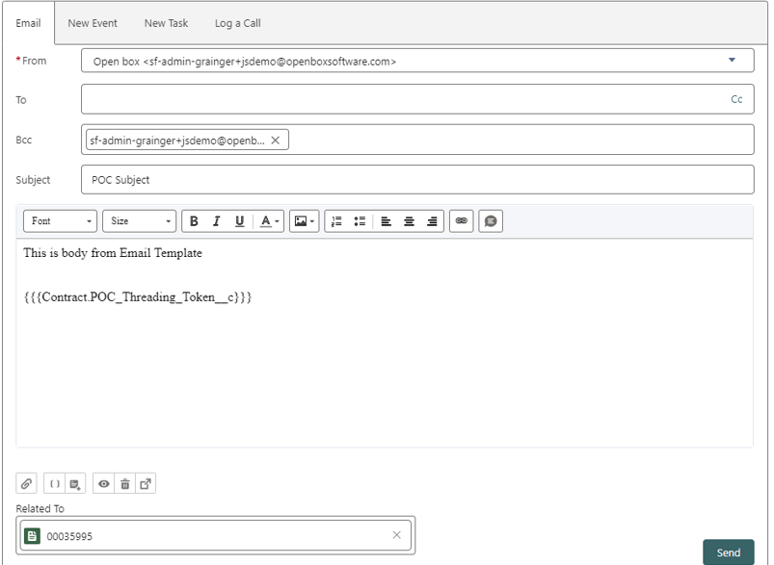
Figure 9: Proof of Concept - Email Template Contains a Threading Token
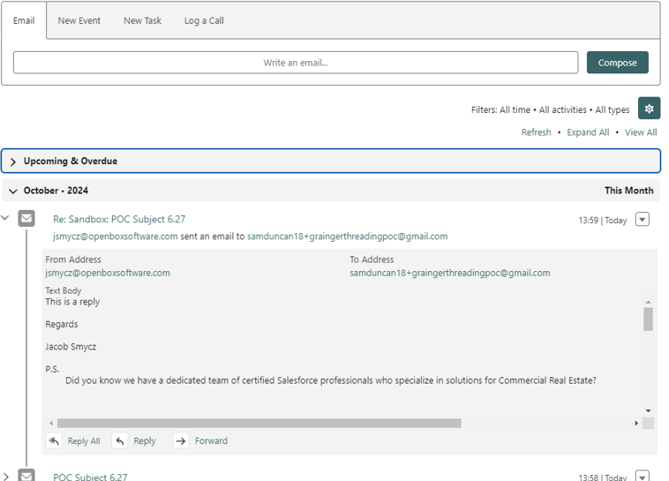
Figure 10: Proof of Concept - Tenant's Email Reply is Displayed in the Opportunity’s Activity Timeline
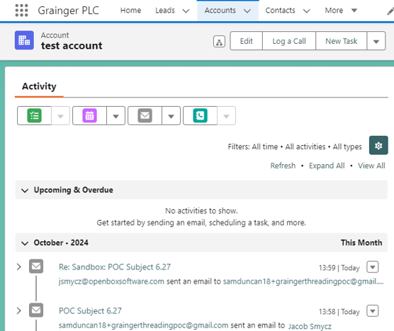
Figure 11: Proof of Concept - Tenant's Email Reply is also Displayed in the Account’s Activity Timeline

Solution Overview
The following provides an overview of the proposed solution’s interfaces and users:
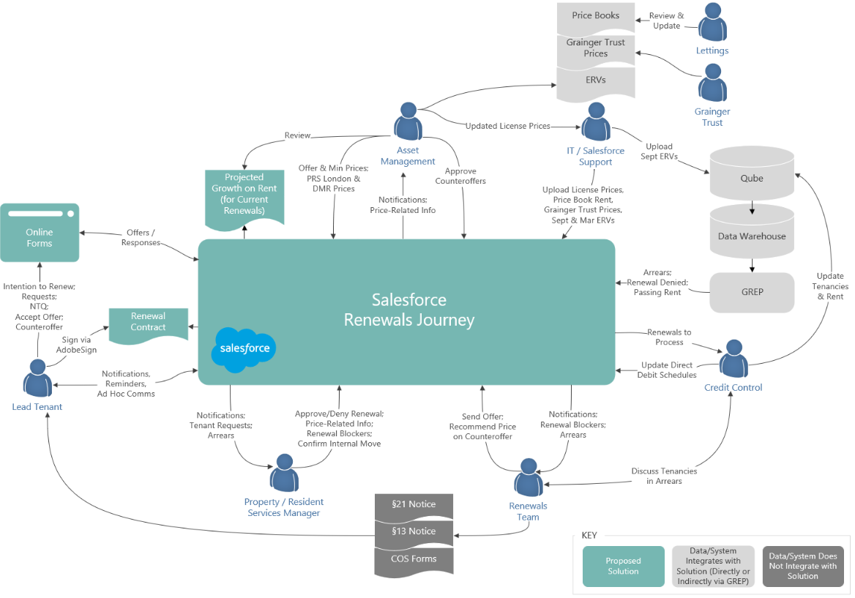

Figure 12: Proposed Solution Context Diagram (Release 1 & 2)
- Data Warehouse – Any current arrears balance for the overall tenancy will be imported from the Data Warehouse (via the GREP integration layer) and updated daily.
- Pricing Spreadsheets – Support users will update Salesforce price books (including ERV price books) by uploading unit pricing and ERV spreadsheets provided by various departments.
  - It is expected that this would require 4-5 hours effort per month, which could be completed either by a Grainger Salesforce administrator or could consume hours from the existing 40 hours per month T&M Open Box support agreement.
  - Given that there are many price book spreadsheets in varying formats, it is not intended that business users would perform the uploads. Moving the price books calculations into Salesforce, and thereby eliminating the need for manual uploads, is expected to be addressed in a future phase.
- Tenants - The lead tenant will receive notifications & reminder emails from Salesforce with a link to provide intention to renew or review the renewal offer(s) via online forms.
  - The forms will be implemented using Form Assembly. Responses will be saved to the corresponding fields on the offer and opportunity.
  - Any requests for a different unit, tenant requests raised during the renewal process, or renewal blockers will be saved as a task linked to the opportunity and assigned to the PM/RSM.
- Property Managers / Resident Services Managers
  - PMs/RSMs will receive notification of renewals to review, tenant requests, and any notice to quit from Salesforce.
  - PMs/RSMs will see where there are arrears or right-to-rent information outstanding on renewals, provide their renewal decision, and capture comments about the tenant on a list of renewals that requires their review (using a LWC data table in Salesforce).
  - Updates to unit condition & pricing considerations will be captured in new fields on the unit and block, as applicable, and displayed in renewal lists.
- Asset Managers
  - AMs will receive notification of pricing and counteroffers to review from Salesforce.
  - AMs will see pricing inputs such as ERV and unit condition, and will adjust offer & minimum prices on a list of renewals that requires their review (using a LWC data table in Salesforce).
    - AMs will continue to capture renewal prices for DMR units and estates that do not have price books from scratch.
  - AMs will use a new Salesforce report calculating projected growth on rent to evaluate renewal pricing.
  - AMs will approve counteroffers via the standard Salesforce approval functionality.
- Renewals Team
  - Renewal negotiators will receive notification of change of sharer requests, counteroffers, and any notice to quit from Salesforce.
  - Renewal negotiators will have access to the following, using a LWC data table in Salesforce:
    - A list of all open renewals that highlights delays and any at risk of missing deadlines.
    - A list of renewals that are ready for their to review, highlighting any with unresolved tenant requests, renewal blockers, arrears, or right-to-rent information outstanding.
  - The current process to manage Change of Sharer requests, consult Credit Control about arrears, and generate Section 13 & Section 21 notices will remain unchanged.
- Credit Control – Interaction with the renewal opportunities will remain unchanged. Qube and direct debit schedules in Salesforce will continue to be updated manually in exactly the same manner as the current process, except that it should no longer be necessary to create or update lease end diaries in Qube.
  - Once the foundational release is complete and the tenancy data model is aligned with Qube, integration to automate these updates can be addressed in a future phase.

Recommended Project Phasing
It is recommended that these projects are phased in incremental releases as follows:
- Release 1 - Single View of Tenancy (SVOC) Foundational Release – This project would be delivered first; this functionality is a prerequisite for the enhanced renewals journey.
  - The solution design will align Qube and Salesforce tenancies, providing a data structure in Salesforce that will enable future integration, including updating Qube on renewal and change of sharer.
- Release 2 - Renewals Journey - The recommended scope of this project overhauls the initial phases in the renewals journey, up to the point that the tenant accepts the offer. Thereafter, the existing renewal process and functionality will remain in place for Release 2.
  - Sprint zero analysis may commence while SVOC Foundations Release is in progress

Future Phases
It is recommended that future project phases be used to deliver functionality that has been identified during requirements analysis, but are out of scope of this proposal.
- Release 3 – Renters’ Rights Enhancements to the Renewals Journey – This release would build upon release 2, providing functionality to support the Renters’ Rights Bill and would aim to go live with the Renter’s Rights Bill:
  - Send tenants a notification of rent increase (Section 13 notice) instead of offers (for applicable agreement types).
  - Customise the renewals journey, including generating alternate documentation and alternate email templates, for:
    - Wales
    - Company Lets
    - Live/Work Units
    - DMR & Affordable Rent Units
  - Tenant Appeals Tracker
  - Give PMs visibility into upcoming rent increases.
  - Display additional information on the renewal opportunity to assist Credit Control (including Direct Debit Authorizations that are not yet 'In Force' & a calculated blended payment charge where rent increases mid-month).
  - Ensure the ‘Audit’ step is not skipped in the renewals process.
  - Differentiate Mid-Term Change of Sharer from renewal opportunities (for reporting).
- Release 4 – Updating Qube on Renewal - This release would enhance the integration with Qube, updating tenancy details and rent charges in Qube on completion of a renewal. This project is dependent on the Salesforce-Qube tenancy mapping that will be implemented in Release 1.
  - It is recommended that this project be completed after the Renters’ Rights Bill comes into force in order to eliminate the need for any rework should updates to Qube change post-Renters’ Rights.

- Release 5 – Additional Renewals Enhancements
  - Automatically update direct debit payment schedules in Salesforce on Renewal and mid-term change of sharer.
  - Provide a new dashboard for Asset Management that displays comparable rent & current performance by estate & unit type.
  - Eviction / §8 Notice Tracker
  - Tenants complete and sign change of sharer forms online.
  - Cater for bulk negotiations for Company Lets.
- Release 6 - Arrears Details & Reminders
  - Provide visibility into arrears details and history on Salesforce (sourced from Qube).
  - Automated notifications to tenants who fall into arrears.
- Other, future projects on the SVOC & Renewals Backlog:

  - Manage & calculate Price Book Rent within Salesforce.
  - Provide visibility into all tenant incidents, complaints, grumbles & satisfaction survey feedback within Salesforce.
Any further enhancements that would deliver significant value may be addressed in subsequent releases.

Release 2 - Renewals Journey
Release 2 overhauls the initial phases in the renewals journey, up to the point that the tenant accepts the offer. Thereafter, the existing renewal process and functionality will remain in place.
The following illustrates the proposed changes to the renewal opportunity stages in release 2:
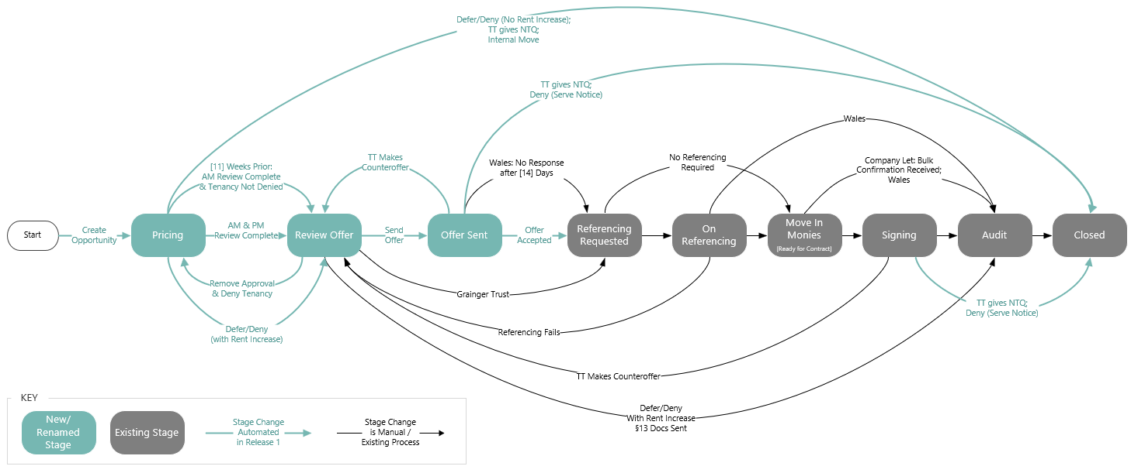
Figure 13: Proposed Renewal Opportunity Stages – Release 2

The following depicts the interaction between existing processes and new functionality to complete the end-to-end renewal in Release 2:
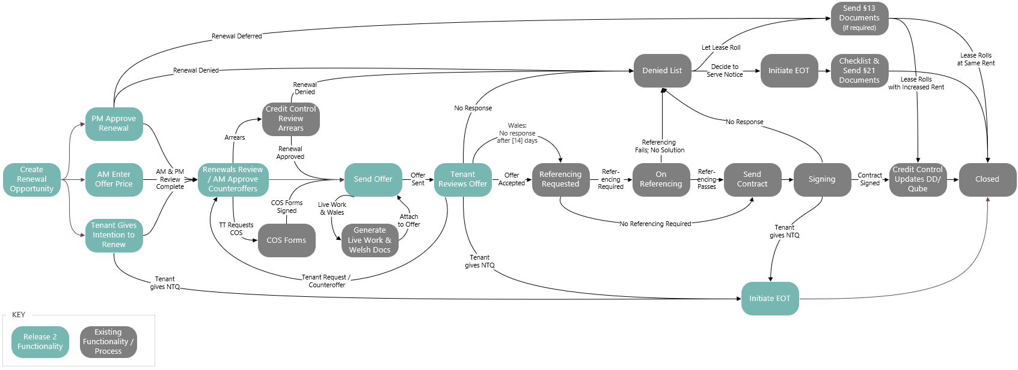

Figure 14: Proposed Relationship between New & Existing Functionality for Release 2

Renters’ Rights & Additional Enhancements to the Renewals Journey (Future Phase)
Additional functionality can be added in subsequent releases to support the future process that will be required post-Renters’ Rights Bill. This functionality was identified during requirements analysis but is out of scope of functionality to be delivered as part of this proposal.
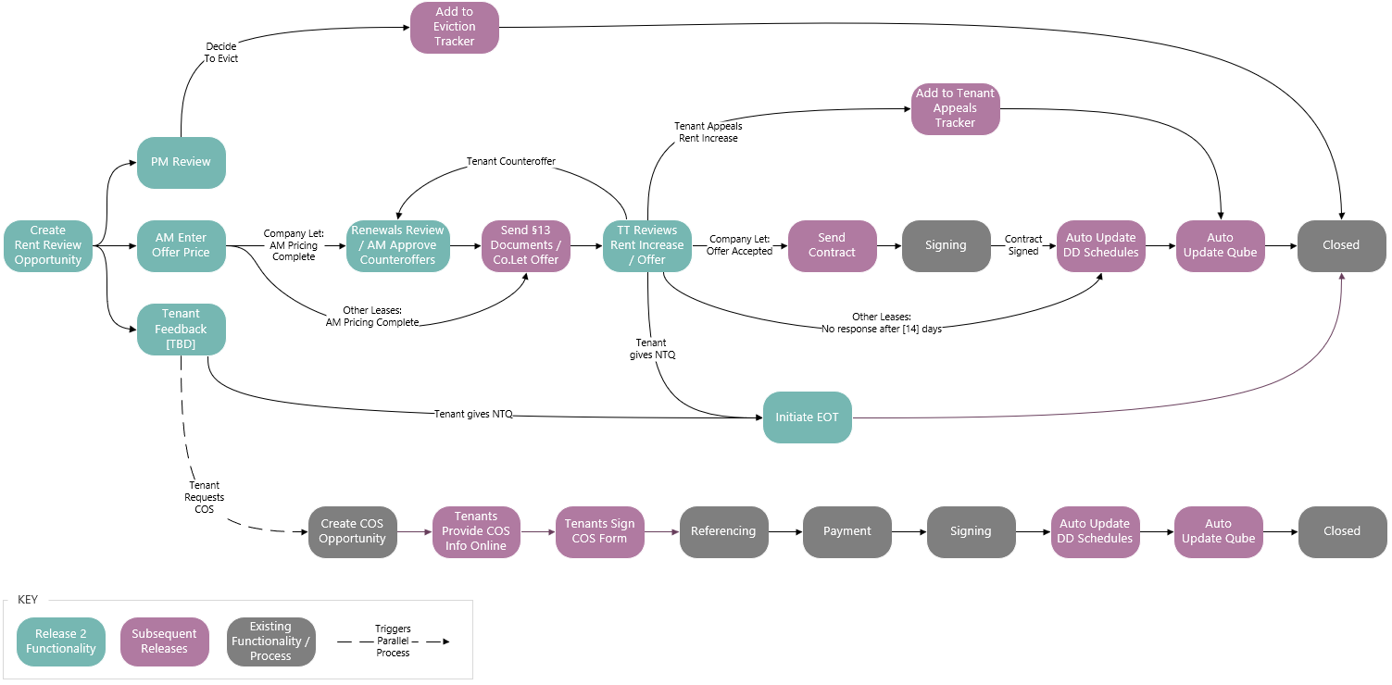
Figure 15: Envisaged Future Functionality to be added Post Renters’ Rights Bill

High-Level Design
This document provides a high level design for the proposed single view of customer and renewals journey enhancements to be implemented on Grainger’s Salesforce org.
This design does not cover the lower level detail (e.g. fields, profiles, automations, validation rules); these will be designed and documented at user story level during the agile delivery phase.

Salesforce Strategy

Document/File Management
The proposed solution does not introduce any new file storage requirements. The existing process may involve files being stored in Salesforce (e.g. PDFs of signed agreements) and this is assumed to continue. Based on current file storage usage within the Grainger Salesforce org (198GB used of 610GB limit) the existing document/file management strategy is considered to be adequate for the next 3+ years.

Data Archival Strategy
Salesforce data storage capacity is limited and is determined by a base allocation at org-level plus a per-user allocation. Any overage will require the purchase of additional storage from Salesforce. Additionally, a high number of records of any one object can result in large data volume (LDV) performance limitations (report timeouts, slow page loads etc.). Thus it is desirable to operate within the allocated capacity if possible and implement an archival strategy to move data off-platform at a point in time where users no longer need to interact with them.
The proposed solution will result in a new Opportunity, Offer and Tenancy records being created every year, in the same way as is currently done. It introduces 14 new Pricebook records every year, and a new PricebookEntry record for every unit for every Pricebook. In order to calculate data volumes, the following assumptions have been used:
- Number of units: 13 000 in year 1, scaling to ±30 000 in year 5
- Number of renewals (or section 13 price increases post Renters’ Rights Bill) per unit per year: 1

Based on these assumptions, the table below shows predicted data storage requirements for the next 5 years:
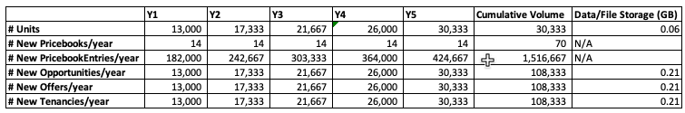
Figure 16: Projected Data Volumes
PricebookEntry record volume is not counted against org storage limits, hence the 1.5M record volume as per Figure 16 is not a concern in terms of data storage requirements. Given that the PricebookEntry object is a low level system object with which users do not interact directly (i.e. they will not be creating list views or reports with complex filter criteria), there are no LDV performance concerns at this time.
Opportunity, Offer and Tenancy record volumes are also well within the org data storage limits and fall below the thresholds that would require consideration for LDV performance issues. Thus there are no requirements to introduce an archival strategy to deal with Opportunity, Offer and Tenancy records within the next 5 years.

Mobile Strategy
The renewals functionality envisaged for this project will be for desktop browsers only. There is no requirement for functionality to be available on mobile devices, either through the Salesforce mobile app or custom mobile app.

Reporting Strategy
Operational reporting needs can be met via Salesforce reports. Should deeper analytical capabilities be required in the future, these can be met via a BI solution such as CRM Analytics or Power BI coupled with an Azure SQL data warehouse.

Third-Party Applications / Add Ons

Form Assembly
The “renewals portal” functionality proposed for this design is dependent on Grainger purchasing a subscription to Form Assembly (https://www.formassembly.com/). At the time of writing it is understood that Grainger will procure an Enterprise FormAssembly subscription that includes a Salesforce connector.
Further consultation may be required to determine the security requirements (especially user authentication) for the “renewals portal” and ensure that the methodology implemented with Form Assembly complies with this.
Depending on how Form Assembly forms are published (either via Form Assembly directly or embedded on the graingerplc.co.uk website), additional work may be required by Grainger and Code to create the pages and style in a way that is consistent with Grainger branding.

Data Model

Entity Relationship Diagram
The following key changes are proposed to the high-level data model in order to support the enhanced renewals journey:

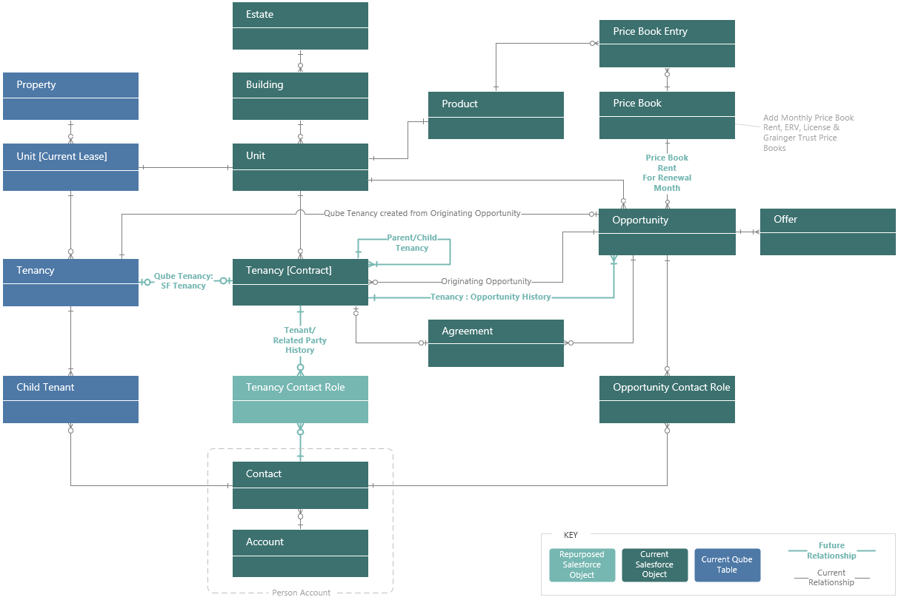
Figure 17: Entity Relationship Diagram

- Price Books
  - New price books would be added to the existing, standard Salesforce object to save the following in Salesforce:
    - Price Book Rent – A separate price book would be created for each month (e.g. Price Book Rent for renewals/new lets taking place in January 2025).
      - These Salesforce price books would also include prices for non-live units and Grainger Trust units.
      - Each renewal opportunity would be linked to the Salesforce price book for the renewal month in order to source the latest price book rent when Asset Management reviews pricing.
    - ERVs - A separate price book would be created for each month for which ERV values are received (e.g. ERV as at March 2025).
      - The existing ERV fields on the Unit object, which do not allow for a history of ERVs to be saved over time, will be hidden.
  - The existing ‘Standard Price Book’ would remain unchanged. Future enhancements may include new lettings using the future dated pricebooks rather than the Standard Price Book.
- Tenancy
  - Per the current process, tenancies originate from a successful opportunity Salesforce, and thereafter Qube remains the system of record for all existing Qube data points on the tenancy. i.e. all changes to existing Tenancy fields will be made in Qube and sent to Salesforce via integration if required.
  - Records that represent a true, Qube tenancy will be added to Salesforce within the existing tenancy [Contract] object with a field to differentiate between “parent” and “child” records. The existing tenancy records (which represent a contract agreement / version of the overall tenancy) will be child records to the new tenancy records.
  - Each tenancy in Salesforce will be mapped one-to-one to a Qube tenancy to facilitate future integration whereby significant updates to contract terms that are managed in Salesforce would be pushed to Qube.
  - The current arrears balance would be added as a new Contract field, saved on the tenancy. This will be updated from Qube daily.
  - The Next Rent Review Date would be added as a new Contract field saved on the tenancy. It is expected that this date, along with the revised renewal process, will replace the need for lease end diaries in Qube (barring exceptions such as recording a renewal denied mid-lease term in Qube). This will be a new field on the tenancy in Salesforce and will not be required to be integrated to Qube.
- Tenancy Contact Role
  - The standard ContractContactRole object, which is not currently populated, will be used be save a full history of all tenants and related parties associated to a tenancy over time. This data would correspond to the ‘Child Tenant’ data in Qube, and would include a start date, end date, role and status for each related party.
- Contacts & Accounts
  - It is recommended that Salesforce becomes the system of record for contact and account (i.e. tenant and related party) data in the future. However, this project will not address those changes and Qube will remain the system of record for tenant data in the meantime. Changes to tenant details (such as email and phone numbers) will continue to be made in Qube which will update Salesforce, per the current integration.
- Offers
  - A new record will be saved on the Offer [Quote] object for each offer sent to a tenant, providing a full offer history.
  - Counteroffer details, the re-offer price suggested by Renewals, and the Asset Management approved re-offer price will be saved as new fields on the Offer [Quote] object. A counteroffer will therefore not create a separate offer record, but will be saved as a response on the offer that was sent to the tenant.

Data Sharing & Security
The existing data sharing and security model for the Grainger Salesforce org will not be updated as part of this project.
The Grainger Salesforce org currently has a public read/write org wide default (OWD) for all key objects (Account, Opportunity, Tenancy) and allows all users to view all records. Where no security requirements exist to restrict visibility, this solution provides full visibility to all users and facilitates easy collaboration (e.g. users are able to update tasks belonging to a colleague when the colleague is absent). It should be noted that this public OWD still allows for editability to be restricted by user/role/profile - for example, Tenancy fields that are mastered in Qube would not be editable by users in Salesforce.
The functionality proposed for this solution does not require any changes to the existing sharing model. Should future requirements necessitate a tighter security model, this can be implemented with the many security mechanisms provided by Salesforce (role hierarchy, sharing rules etc.).

Integration
It is expected that Grainger, or an integration partner, would be responsible for developing a new import of tenancy arrears, passing rent and other required tenancy data from the data warehouse (or Qube) into Salesforce, via the GREP integration layer. The details of this integration will be gathered during further requirements gathering sessions, for the purpose of the solution it is assumed that it runs on a daily basis and is operated and monitored by a Grainger team to ensure successful completion of each run.

Data Migration
A number of once-off data migrations would be required before the functionality can go live.
Data migrated from Qube would be provided to Open Box in spreadsheets which will be loaded into Salesforce.
Open Box will not cleanse any of the data provided; nor will Open Box validate any of the data provided, beyond the minimum required to load the data into Salesforce.

Price Book Rent
The price book rent will be loaded into new price books in Salesforce from:
- The latest price book rent spreadsheet for each estate, with pricing at a unit level.
- The existing spreadsheet containing all Grainger Trust unit prices.
- All existing license prices (loaded, for example, for 36 months into the future), using the current rent for each non-live unit from Qube.

ERVs
The latest September ERV file and March ERV file will be loaded into new price books in Salesforce.

Unit Condition from Qube
The existing unit condition (unit description) will be migrated from Qube and saved on a new field on each unit.

Next Rent Review Date from Qube
Where a lease is rolling, the Next Rent Review Date will be migrated from the ‘Event Date’ on active ‘Lease End’ diaries in Qube onto a new field on the tenancy.
This data will only be migrated for current tenancies.

Salesforce Licensing
It is understood that all users of the first release of the enhanced Renewals process solution have already been provisioned with full Salesforce licenses. It should therefore not be necessary to purchase additional licenses.
It is not expected that the solution will require any additional costs for data and file storage. This is based on current understanding and scoped features and is subject to change if additional requirements (e.g. file storage) are introduced.

Support
Open Box will provide post go-live support for 10 working days immediately following the production deployment.

Training
To facilitate the training process, Open Box will train a designated Grainger representative and provide a single user guide. The user guide content will be limited to the renewals functionality delivered in the initial release; Grainger may add any existing functionality, such as referencing, to the guide afterwards.
Open Box will not conduct any change management or end-user training; this will be the responsibility of Grainger.

Prerequisites
The Single View of Tenancy foundation project cannot be completed until the following is completed:
- Grainger or integration partners to add integration to import tenancy arrears, passing rent, renewal denied flag and additional tenancy data as required from the data warehouse or from Qube into Salesforce on a daily basis.
- Grainger or integration partners to modify any existing integration that references the Salesforce tenancy object, to incorporate the new Qube to Salesforce tenancy mapping (if applicable).
The renewals project cannot be completed until the following is completed:
- New functionality to identify DMR and affordable rent units (to be addressed in the Grainger Trust Leasing Journey project).

Exclusions
The following is not included in the cost or scope of Release 1 of this project:
- Solution documentation, other than user stories and a user guide.
- Third-party costs, license fees, subscriptions or services.
- Data cleansing or enriching.
- Grainger will be responsible for styling pages implemented within Form Assembly.
- Grainger will be responsible for the analysis, developing and testing a new import of tenancy data (including arrears and renewal denied indicator) from the data warehouse or Qube into Salesforce.
- Future functionality as detailed in the Future Phases.
- Additional functionality not in scope:
  - Commercial lease renewals.
  - Replacing the existing tenant portal (other than replacing the functionality to review & respond to renewal offers).
  - Reporting (other than to provide a single AM report).
  - Integration with Qube, MRI Evolution, MyGrainger app or other data sources.
  - Updates to GREP integration or GREP data (including the XREF mapping table).
  - Generating or sending Section 13 documents through Salesforce.
  - Generating or sending Section 21 documents, monitoring the process to serve notice, replacing the Section 21 checklist, or creating an End of Tenancy on decision to serve notice.
  - Automation of the arrears monitoring or review process.
  - Creating tenancy data in Salesforce for historical/ended tenancies.
  - Moving the ‘Denied List’ from Qube into Salesforce.

  - Salesforce will not update the ‘Denied’ flag (lease end diary) in Qube.

Assumptions
The following key assumptions have been made; incorrect assumptions may impact project cost and timelines:
- The renewals process does not require Salesforce to contain a history of tenancy arrears, arrears details, or tenant/account-level arrears information. It is sufficient to initially save a single balance per tenancy that will be overwritten on a daily basis.
  - More detailed information may be imported from Qube into Salesforce in the future, however this will form part of a future phase. This could include arrears history, monthly payments and other information maintained on the tenancy in Qube.
- It will be possible for Grainger to import tenancy arrears from the data warehouse or Qube. Note importing the data from Qube would require an enhancement to the Qube web service.
- Email threading functionality has been developed as part of the Right to Rent project; any further enhancements required for the renewals journey are expected to be minimal.
- The “renewals portal” implemented with Form Assembly will not require each user to have a username and password, but will implement a one time password (OTP) via email to ensure PII information is suitably protected.
  - Note that the existing functionality and security controls delivered by the Adobe Sign application will remain in place for contract signing within the renewals process.
- The following will not be required as part of the annual rent increase process, once the Rent Reform Bill becomes law:
  - Generating, sending & signing of renewal contracts for the majority of units/lease types.
  - Reviewing right-to-rent validity and any tenancy arrears before sending notification of rent increases. These will be managed via separate (potentially parallel) processes.
  - Processing change of sharer and other lease changes (such as payment frequency) as part of a rent increase. This will be managed via a separate (potentially parallel) mid-term change processes.
  - Dealing with tenant requests, complaints, and requests to move to a different unit as part of a rent increase. These will be managed via separate (potentially parallel) processes.
  - Ability to delay the rent review process, other than to not increase the rent and wait until the next lease start anniversary before reviewing rent again. Although, it will likely be necessary to delay the rent increase, if a tenant appeals.

Detailed Costs & Timelines
Open Box will provide the following services:
- An agile sprint team delivering in 3 week sprints. The team will be staffed to include the following skill sets as required:
  - Salesforce Technical Architect
  - Business Analyst
  - Developer
  - Quality Assurer
  - Project Manager
- UAT support to assist in the UAT process and fix any new bugs identified.
- Production deployment & and post-go live Support immediately following the production deployment.
All amounts are quoted in GBP (£) and exclude VAT, if applicable.
Project costs will be billed monthly, in arrears.
This quotation is valid until 31st December 2024 to secure the 2024 rates.
All consultancy and all development work will be completed by Open Box offsite.
- It is not expected that the project requires Open Box resources onsite. Where onsite personnel are required, all reasonable expenses for travel and subsistence shall be reimbursed by Grainger. Open Box shall not bill any mark-up or administration fee onto any such expenses. Approval for expenses shall be obtained from Grainger prior to being incurred.

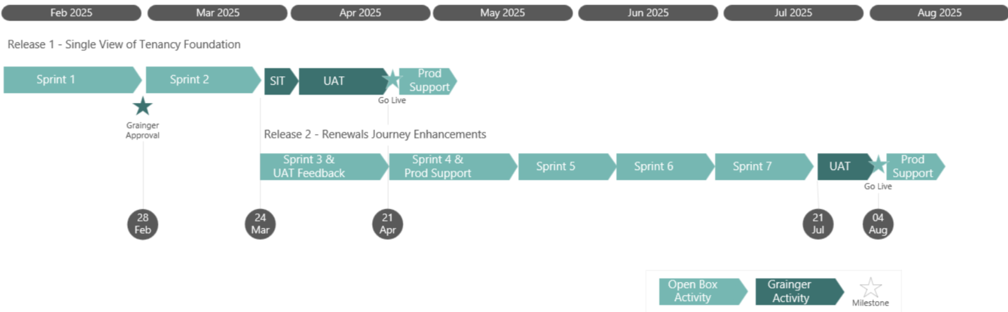
Figure 18: Estimated Timelines

Release 1 - Single View of Tenancy
The total cost of this release is estimated to be £98 370.
The total duration of this this release is expected to be 15 weeks (including 2 weeks of SIT and 2 weeks of UAT) as well as an additional 2 weeks for post go-live support.
This release is estimated to go live on 27th March 2025, assuming a project start date of 2nd January 2025.
Phase | Duration | Lower Bound | Upper Bound
Sprint 0 | 2 weeks | £4,095 | £4,095
2 Sprints | 6 weeks | £81,900 | £81,900
User guide updates | Done in parallel with sprints | £1,575 | £1,575
UAT | 4 weeks | £7,200 | £7,200
Production Deployment & Post Go-Live Support | 2 weeks | £3,600 | £3,600
Total | 14 weeks | £98,370 | £98,370

Release 2 – Renewals
Release 2 which is focused on the renewals functionality is currently projected to take 4 – 5 sprints to deliver to UAT. This will be confirmed after Sprint 0 has been completed to ensure any additional complexity can be included if required.
The total cost of this release is estimated to be £176 175 – £217 125.
The total duration of this release is expected to be 16-19 weeks (including 2 weeks UAT) as well as an additional 2 weeks for post go-live support.
This release is estimated to go live on 10th July 2025, assuming a project start date of 27th February 2024.
Phase | Duration | Lower Bound | Upper Bound
4-5 Sprints | 14 - 17 weeks | £163,800 | £204,750
User guide updates | Done in parallel with sprints | £1,575 | £1,575
UAT | 2 weeks | £7,200 | £7,200
Production Deployment & Post Go-Live Support | 2 weeks | £3,600 | £3,600
Total | 18 - 21 weeks | £176,175 | £217,125

Dependencies
Costs and timelines are contingent on:
- Prerequisites detailed above.
- Grainger making an internal product owner or project sponsor available to facilitate decision-making.
- The appropriate Grainger stakeholders being available throughout the project, including participation in the activities (and within the timelines) detailed in the Delivery Approach.
- Grainger delivering any required information or content (such as document and emails templates) in a timely manner.
- Grainger completing UAT within the time period specified above.

Delivery Approach
The delivery approach will be based on the agile SCRUM framework. Iterative delivery is achieved through a series of 3-week sprints.
An agile delivery approach allows for the early delivery of outcomes and provides flexibility to adjust for any unforeseen opportunities or issues uncovered during the project.
A backlog will be maintained to track outcomes to be delivered and indicate priority of these outcomes relative to each other. The backlog will be a living artifact that will evolve as Open Box and Grainger collaborate and will serve as the single source of truth with regards to scope.
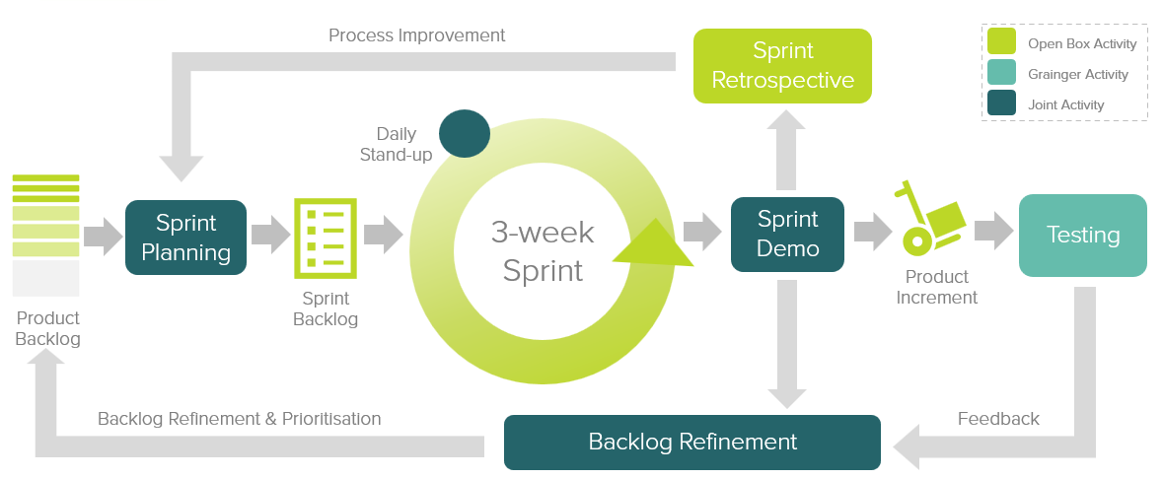
Figure 19: Agile Delivery Approach
Grainger representatives will be required to particulate in the following during each sprint cycle:
- Backlog Refinement – Open Box and Grainger representatives will meet to prioritise user stories on the backlog as well as review and agree on acceptance criteria for user stories at the top of the backlog.
- Sprint Planning – Outcomes on the backlog will be selected for the next sprint.
- Demo – Open Box will meet with Grainger representatives to demonstrate the outcomes delivered in the past 3-week period.
- Testing – Open Box will be responsible for unit testing and QA testing of functionality. Grainger representatives will conduct user acceptance testing of new functionality delivered in each sprint and provide feedback within 1 week of the demo.
- Stand Up – Regular, 15-minute stand up calls will be held to report on progress; the Grainger product owner is expected to participate regularly in these calls to provide feedback and give input on any questions that arise.
Feedback from demos and testing will be classified as either bugs or enhancements (depending on the user story and acceptance criteria). Bugs will be fixed in a subsequent sprint, whereas enhancements will be incorporated into the backlog and prioritized accordingly.
If it is expected that the critical functionality can no longer be delivered within the estimated cost and timeline, this will be communicated to Grainger who may choose to resolve this by adjusting the project scope and/or cost & timelines accordingly.

UAT
Designated Grainger business users will be given access to a UAT sandbox to test the functionality end-to-end and ensure that the overall solution is functioning as expected.
Issues raised will be classified as bugs or enhancements (as above). Bugs will be fixed during the UAT period. Any other enhancements or new requirements will be added to the backlog for future development.

Project Management
Open Box will deliver a progress report to Grainger on a regular basis, that will include:
- General status update
- Project risks
- Project milestones & timeline forecast based on the current scope of release 1.
Regular updates regarding any significant changes in scope or cost will be delivered to Grainger as and when they occur.

Availability
All work will be completed by Open Box offsite.
Open Box resources will be contactable and available for meetings via conference calls/video conferences:
- Monday to Friday 9am – 6pm South African time which corresponds to 7am – 4pm GMT, excluding public holidays.

Acceptance
The parties hereto, each acting under due and proper authority, have executed this Agreement as of the day, month and year first written below.

For and on behalf of Open Box Software For and on behalf of Grainger plc

Signature: _____________________ Signature: _____________________
Name: Sam Duncan Name: Eliza Pattinson
Position: Salesforce Director Position: Director of Operations and Asset Management
Date: _____________________ Date: _____________________

